**SDF LAB WEEK 2**

Ques 1)

#include<iostream>

#include<stdio.h>

#include<stdlib.h>

using namespace std;

int main()

{

//1st method

int *p=NULL;

p = new int;

*p = 20;

//2nd method

float *q=new float(10.12);

cout<<"Value of p ="<<*p;

cout<<"\nValue of q ="<<*q;

delete p,q;

return 0;

}

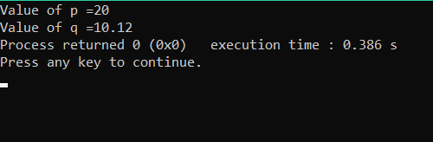

Ques 2)

#include<iostream>

#include<stdio.h>

#include<stdlib.h>

using namespace std;

int main()

{

int arr[]={10,100,200};

int *ptr = arr;

for(int i=0;i<3;i++)

{

cout<<"\nValue of var["<<i<<"] = "<<*ptr;

cout<<"\nAddress of var["<<i<<"] = "<<ptr;

ptr++;

}

ptr--;

for(int i=2;i>=0;i--)

{

cout<<"\nValue of var["<<i<<"] = "<<*ptr;

cout<<"\nAddress of var["<<i<<"] = "<<ptr;

ptr--;

}

return 0;

}

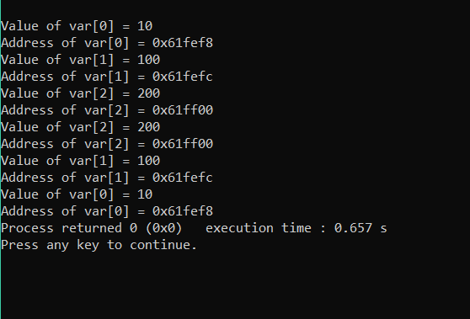

Ques 3)

#include <iostream>

using namespace std;

int main() {

int num;

cin>>num;

float* ptr;

ptr = new float[num];

cout<< "Enter GPA of students: " <<endl;

for (int i = 0; i<num; ++i)

{

cout<< "Student " <<i + 1 << ": ";

cin>> *(ptr + i);

}

cout<< "\nDisplaying GPA of students." <<endl;

for (int i = 0; i<num; ++i) {

cout<< "Student" <<i + 1 << " :" << *(ptr + i) <<endl;

}

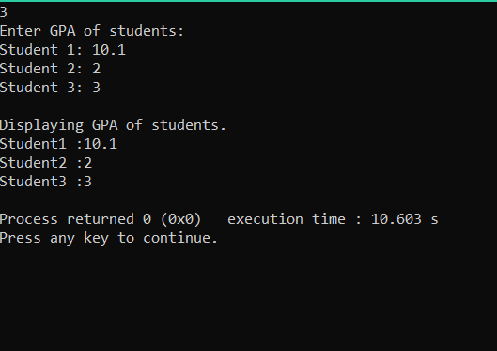return 0;

}

Ques 5)

#include<iostream>

#include<stdio.h>

#include<stdlib.h>

using namespace std;

int main()

{

int n,i;

cin>>n;

int *p=new int[n];

//entering values in array

for(i=0;i<n;i++)

cin>>*(p+i);

//Method

int mx=*(p+0);

for(i=1;i<n;i++)

if(*(p+i)>mx)

mx=*(p+i);

cout<<"\nLargest value = "<<mx;

return 0;

}

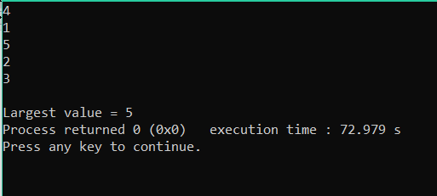

Ques 6)

#include<iostream>

#include<stdio.h>

#include<stdlib.h>

using namespace std;

int main()

{

int n,i,sum=0;

cin>>n;

int *p=new int[n];

//entering values in array

for(i=0;i<n;i++)

{

cin>>*(p+i);

sum+=*(p+i);

}

cout<<"\nSum of array integers = "<<sum;

return 0;

}

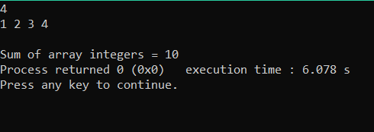

Ques 7)

#include<iostream>

#include<stdio.h>

#include<stdlib.h>

using namespace std;

int main()

{

int i,n,ctr=0;

int *p=new int[5]{1,2,3,4,5};

cout<<"Enter the search integer: ";

cin>>n;

for(i=0;i<n;i++)

{

if(*(p+i)==n)

{

cout<<i;

ctr=1;

}

}

if(ctr==0)

cout<<"\nIt is not present in array";

return 0;

}

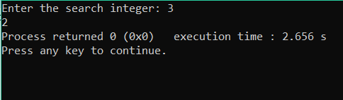

Ques 8)

#include<iostream>

#include<stdio.h>

#include<stdlib.h>

using namespace std;

int main()

{

int i,no,n,ctr=0;

cout<<"Size of the array: ";

cin>>n;

int *p=new int[n];

cout<<"Enter the array values: ";

for(i=0;i<n;i++)

cin>>*(p+i);

cout<<"Enter the search integer: ";

cin>>no;

for(i=0;i<n;i++)

{

if(*(p+i)==no)

{

cout<<i<<" ";

ctr=1;

}

}

if(ctr==0)

cout<<"\nIt is not present in array";

return 0;

}

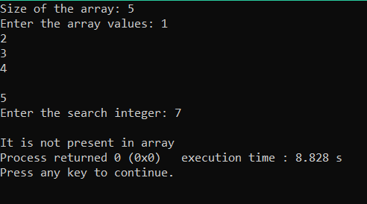

Ques 9)

#include<iostream>

#include<stdio.h>

#include<stdlib.h>

using namespace std;

int main()

{

int *p=new int[5]{5,3,2,1,4},i,j,temp=0,n=5;

cout<<"\nOriginal array\n";

for(i=0;i<n;i++)

cout<<*(p+i)<<" ";

cout<<"\nReverse array\n";

for(i=n-1;i>=0;i--)

cout<<*(p+i)<<" ";

for(i=0;i<n;i++)

{

for(j=i+1;j<n;j++)

{

if(*(p+i)>*(p+j))

{

temp=*(p+i);

*(p+i)=*(p+j);

*(p+j)=temp;

}

}

}

cout<<"\nSorted array\n";

for(i=0;i<n;i++)

cout<<*(p+i)<<" ";

return 0;

}

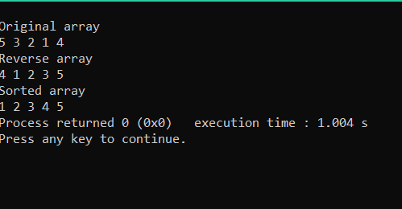

Ques 10)

p = 0x7ffe36d33440, ptr = 0x7ffe36d33440 *p = 3, *ptr = 0x7ffe36d33440 sizeof(p) = 4, sizeof(*p) = 4 sizeof(ptr) = 4, sizeof(*ptr) = 20

Ques11.

#include<iostream>

using namespace std;

int main()

{

int r,c,i,j;

cout<<"Enter no. of rows and columns for array: ";

cin>>r>>c;

int *arrayPtr = new int[r*c];

cout<<"Enter "<<r*c<<" values : ";

for(i=0;i<r;i++)

{

for(j=0;j<c;j++)

{

cin>>*(arrayPtr + i*c+j);

}

}

for(i=0;i<r;i++)

{

for(j=0;j<c;j++)

{

cout<<*(arrayPtr + i*c+j)<<" ";

}

cout<<endl;

}

return 0;

}

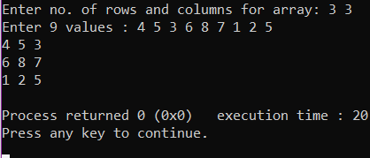

Q12. #include<iostream>

using namespace std;

int main()

{

int r,c,i,j;

cout<<"Enter no. of rows and columns for array: ";

cin>>r>>c; int arr[r][c];

int (*arrayPtr)[r][c] = &arr;

cout<<"Enter "<<r*c<<" values : ";

for(i=0;i<r;i++)

{

for(j=0;j<c;j++)

{

cin>>(*arrayPtr)[i][j];

}

}

for(i=0;i<r;i++)

{

for(j=0;j<c;j++)

{

cout<<(*arrayPtr)[i][j]<<" ";

}

cout<<endl;

}

return 0;

}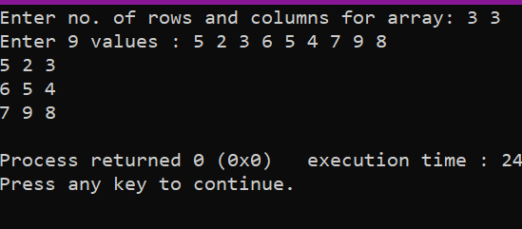

Q13. #include<iostream>

using namespace std;

int main()

{

int i,j,k;

int array[2][3][4] = {

{ {3, 4, 2, 3}, {0, -3, 9, 11}, {23, 12, 23, 2} },

{ {13, 4, 56, 3}, {5, 9, 3, 5}, {5, 1, 4, 9} }

};

int (*arrayPtr)[2][3][4] = &array;

for(k=0;k<2;k++)

{

for(i=0;i<3;i++)

{

for(j=0;j<4;j++)

{

cout<<(*arrayPtr)[k][i][j]<<" ";

}

cout<<endl;

}

cout<<endl;

}

return 0;

}

